Preparing a Manuscript for Submission to an Optica Meeting or Conference [Title Should Be in Bold, 18-Point Type and Centered, Use Title Case]

Author name(s) [10-point type, centered, bolded]
Author affiliation and full address (8-point type, centered, italicized)
Author e-mail address: (8-point type, centered, italicized)

Abstract: Indent left and right margins 0.5 in. (1.27 cm), justify the paragraph (on both right and left), and use the same font as in the body of the paper. Your abstract should be an explicit summary of the paper that states the problem, the methods used, and the major results and conclusions. © 2026 The Author(s) [10-point type, centered]

1. Main Text
  - Required Elements
All PDF submissions must contain the following items in order to be published:
- Complete title.
- Complete listing of all authors and their affiliations.
- Self-contained 35-word abstract (indexers such as Google Scholar will not index papers that do not contain abstracts).
- Appropriate copyright statement following the abstract. By default, the copyright statement will appear as 2026 The Author(s).
- Permission and attribution for any trademarked or copyright images. Note that images of people or images owned or trademarked by other entities (including well-known logo's or cartoon characters for example) will also require official written permission.
- The length of the full paper should not exceed 2 pages. An additional third page can be used exclusively for references.
  - Sections of a paper
The conference paper has a clear structure as suggested below.
- The introduction section begins with a paragraph introducing the research and its relevance to the community.
- Subsequently, the state-of-the-art is shown. A “However” passage comments on what the field is still missing.
- Finally, an “In this paper” paragraph concisely outlines how these issues have been addressed and what the current paper is about.
- The paper continues with a section on the operation principle, methods, experiments, simulations, etc. Sections with headings can be added as needed.
- The results are summarised in the conclusions. This is also the place for an outlook.
- The paper ends with the acknowledgements and references.
  - Typographical Style
The appearance of this document reflects the requirements of the style guide. Since there is no typesetting or copy-editing of summaries, the use of this style guide is critical to provide a consistent appearance. The first line of the first paragraph of a section or subsection should start flush left. The first line of subsequent paragraphs within the section or subsection should be indented 0.2 in. (0.62 cm).
  - Author Names and Affiliations
Author names should be given in full, with first initials spelled out to assist with indexing. Affiliations should follow the format division, organization, and address—and complete postal information should be given. Abbreviations should not be used.
  - Abstract
The abstract should be limited to no more than 35 words. It should be an explicit summary of the paper that states the problem, the methods used, and the major results and conclusions. If another publication author is referenced in the abstract, abbreviated information (e.g., journal, volume number, first page, year) must be given in the abstract itself, without a reference number. (The item referenced in the abstract should be the first cited reference in the body.)
  - Notation
    - General Notation
Notation must be legible, clear, compact, and consistent with standard usage. Acronyms should be defined at first use.
    - Math Notation
Equations should be centered, and equation numbers should only appear to the right of the last line of the equation, in parentheses. For long equations, the equation number may appear on the next line. For example:

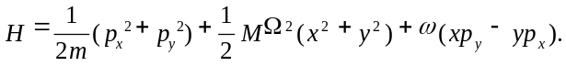 (1)
In-line math of simple fractions should use parentheses when necessary to avoid ambiguity—for example, to distinguish between 1/(n-1) and 1/n-1. Exceptions to this are the proper fractions, such as , which are better left in this form. Summations and integrals that appear within text such as 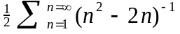 should have limits placed to the right of the symbol to reduce white space. When mentioned in the core of the text, all variables should appear as in the equations.
2. Tables and Figures
Figures and illustrations should be incorporated directly into the manuscript, and the size of a figure should be commensurate with the amount and value of the information conveyed by the figure. Figures and tables should be centered (except for small figures less than 2.6 in. or 6.6 cm in width, which may be placed side by side) and located inside paper margins. Text should not wrap around figures or tables; table captions (10-point font) should be centered above tables, and figure captions (10-point font) should be centered below figures. Both should appear as close as possible to where they are mentioned in the main text.
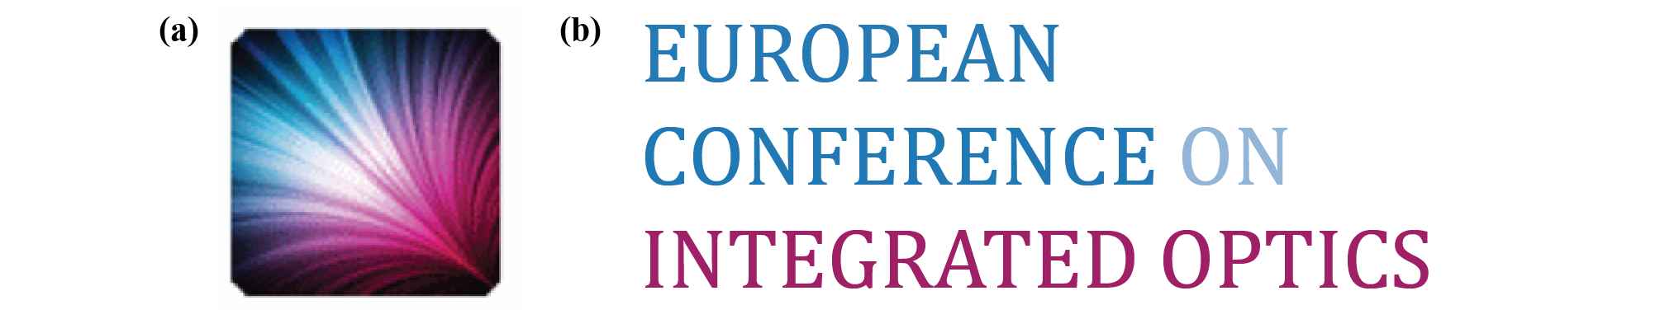
Fig. 1. (a) Logo of the conference. (b) Name of the conference.

No more than three figures should generally be included in the paper. No part of a figure should extend beyond text width, and text should not wrap around figures. Please provide permission and attribution for any trademarked or copyright images.
Table 1. Sample Table

One | Two | Three
Eins | Zwei | Drei
Un | Deux | Trois

3. References
References should appear at the end of the paper in the order in which they are referenced in the body of the paper. The font should be 8 point, and the references should be aligned left. The full list of authors should be provided. We strongly recommend adding the DOI for the reference.
Within the main text, references should be designated by a number in brackets [1], and they should be followed by a comma or period [2]. Two references cited at once should be included together [3,4], separated by a comma, while three or more consecutive references should be indicated by the bounding numbers and a dash [1–4]. Comprehensive journal abbreviations are available on the Crossref web site: http://www.crossref.org/titleList/.

[1] C. van Trigt, “Visual system-response functions and estimating reflectance,” JOSA A 14, 741-755 (1997). DOI: doi.org/10.1364/josaa.14.000741.

[2] David F. Edwards, “Silicon (Si)” in Handbook of optical constants of solids, E.D. Palik, ed. (Academic, Orlando, Fla. 1985). DOI: https://doi.org/10.1016/B978-012544415-6.50027-3.

[3] Author(s), "Title of paper," in Title of Proceeding, (Institute of Electrical and Electronics Engineers, New York, 1900), pp. 00-00. DOI: XX.XYZW/XYZ-X.

[4] Author(s), "Title of paper," in Title of Proceedings, Name(s), ed(s)., Vol. XX of OSA Proceedings Series (Optical Society of America, Washington, D.C., 1900), pp. 00-00. DOI: XX.XYZW/XYZ-X.

